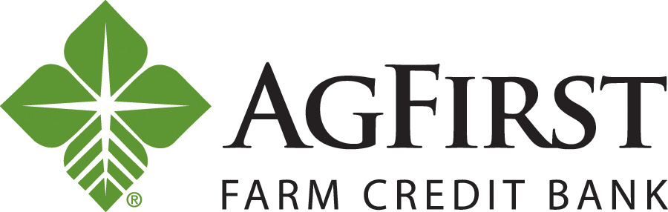

1401 Hampton Street | PO Box 1499 | Columbia, SC 29202-1499 | 803.799.5000 | agfirst.com

NEWS RELEASE Contacts:
Donna J. Camacho, Director of Communications
dcamacho@agfirst.com; 803-753-2251
Joy M. Upchurch, Vice President-Marketing
jupchurch@agfirst.com; 803-753-2379

for release

FRIDAY, JANUARY 15, 2010

AgFirst Farm Credit Bank Announces
Results of Director Elections

Columbia, s.c.— AgFirst Farm Credit Bank announced today the results of recent director elections.

Jack W. Bentley Jr., of Tignall, Ga., Alan Marsh of Madison, Ala., and Bobby E. McCollum Jr., of Polkton, N.C., were elected for four-year terms beginning January 1, 2010. In addition, Bonnie V. Hancock, of Wake Forest, N.C., was appointed by the board as an “outside director” for a four-year term beginning January 1, 2010. (An outside director is one who is not a stockholder, director or employee of a Farm Credit institution.) Hancock is replacing Kenneth A. Spearman, of Winter Haven, Fla., who was recently appointed to the Farm Credit Administration board of directors by President Barack Obama.

Re-elected to the AgFirst board for four-year terms were M. Wayne Lambertson of Pocomoke City, Md., Robert H. Spiers Jr., of Stony Creek, Va., and James L. May of Waynesburg, Ky.

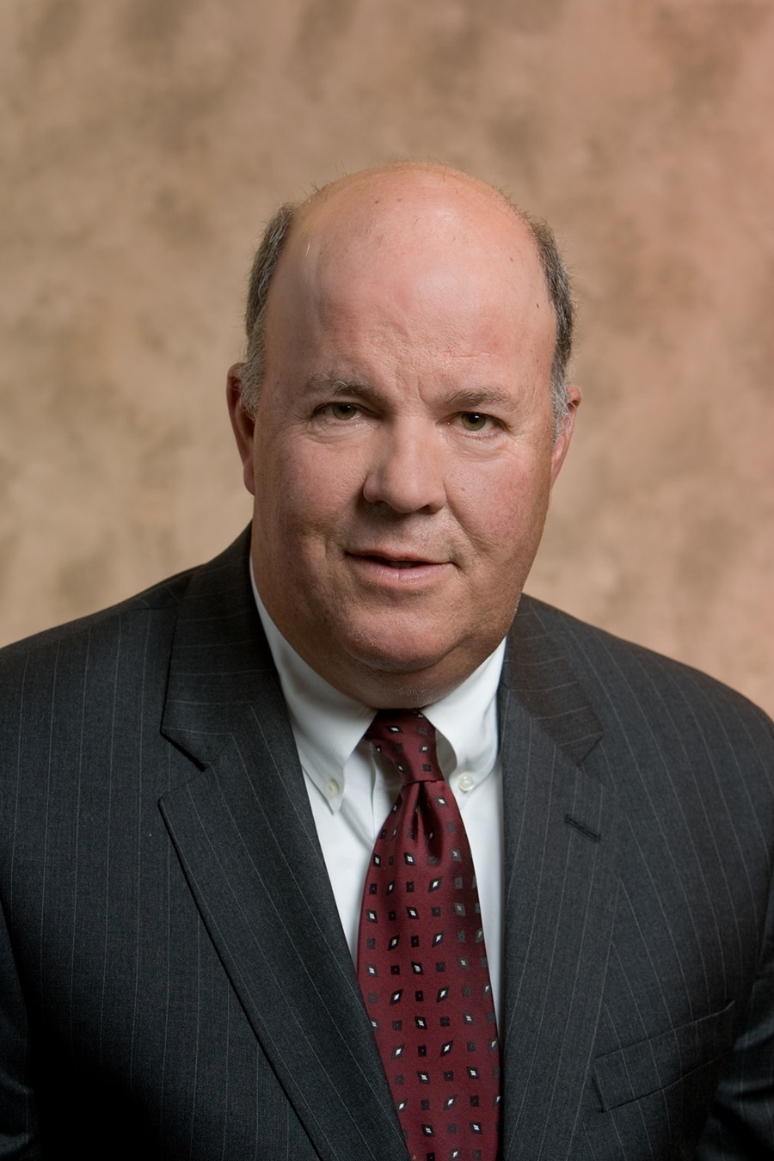
Jack W. Bentley, Jr.
A dairy farmer in Tignall, Ga., Bentley is a graduate of Clemson University with a bachelor’s degree in Agriculture Mechanization and Business. He owns and operates A&J Dairy, a 270-cow dairy that includes 583 acres of pasture, crop and timberland, and an additional 500 acres of leased farmland. Bentley is a director of AgGeorgia Farm Credit, headquartered in Perry, Ga., and has served on its board since 1985. He also is a director for Southeast United Dairy Industry Association and the Wilkes County Farm Bureau. A member of the Wilkes County Board of Tax Assessors, Bentley is also past board chairman for Farm Service Agency.

Alan Marsh
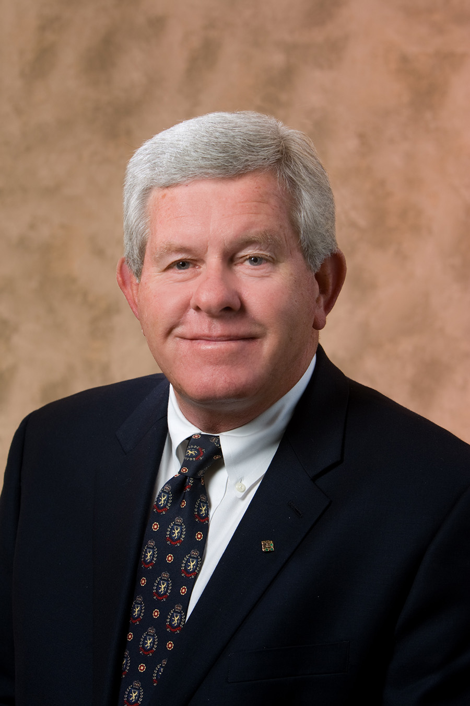
A third-generation farmer, Marsh is owner and operator of Marsh Farms in Madison, Ala. His operation consists of 3,000 acres of row crops, including 560 acres of cotton, a double crop of soybeans and wheat on 1,700 acres, 375 additional acres of soybeans and 365 acres of corn. He is a current director and past chairman of the board of First South Farm Credit, headquartered in Jackson, Miss., and has served on its board since 1992. Marsh is a board member of Limestone County Farmers Federation and is president and stockholder of South Limestone Co-op Gin. He is also a delegate on the national Cotton Council. He is a member of the Alabama Cattlemen’s Association and an advisory board member for Staplcotn®, a cotton cooperative association.

Bobby E. McCollum Jr.

McCollum is a poultry operator in Polkton, N.C. His operation includes eight broiler houses that produce 750,000 heavy broilers per year. McCollum also has a 100-head brood cow/calf commercial herd on 200 acres of pasture, and grows 100 acres of pine timber, as well as hay, soybeans, wheat and corn. He is a member of Carolina Farm Credit, headquartered in Statesville, N.C., and served on its board of directors from 1992-2009. He is vice chairman of the Anson County Farm Bureau board of directors and also served on the FCCServices Leadership Institute Planning Committee for three years. McCollum is a current member of the Anson County Cattlemen’s Association, and a member of the North Carolina Farm Bureau, serving on their Poultry Advisory Committee.

Bonnie V. Hancock
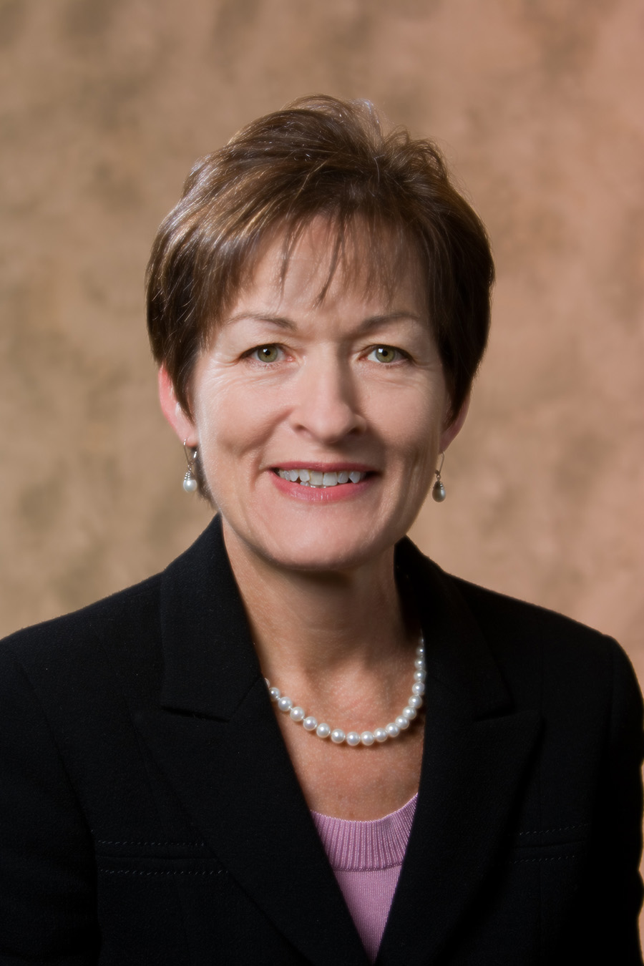
Hancock is Executive Director of the Enterprise Risk Management Initiative at N.C. State University. She also lectures and teaches courses in financial management, enterprise risk management, strategy and financial statement analysis. Prior to joining NCSU, she worked with Progress Energy, as senior vice president of finance and information technology and later as president of Progress Fuels, a subsidiary that produces and markets gas, coal and synthetic fuels, and operates fuel terminals and ash management facilities.
Hancock is a graduate of Georgetown University with a master’s degree in taxation. She is also a graduate of the College of William and Mary with a bachelor’s degree in business administration with an accounting major. She is a recipient of the Sells Award, which recognizes outstanding performance on the Uniform CPA Examination. She lives in Wake Forest, N.C., and is a member of the board of directors of the Marble Kids Museum, where she serves as a finance committee member, and a member of the board of directors of the N.C. Coastal Pines Girl Scout Council, where she also serves as a finance committee member.

James (Jim) L. May
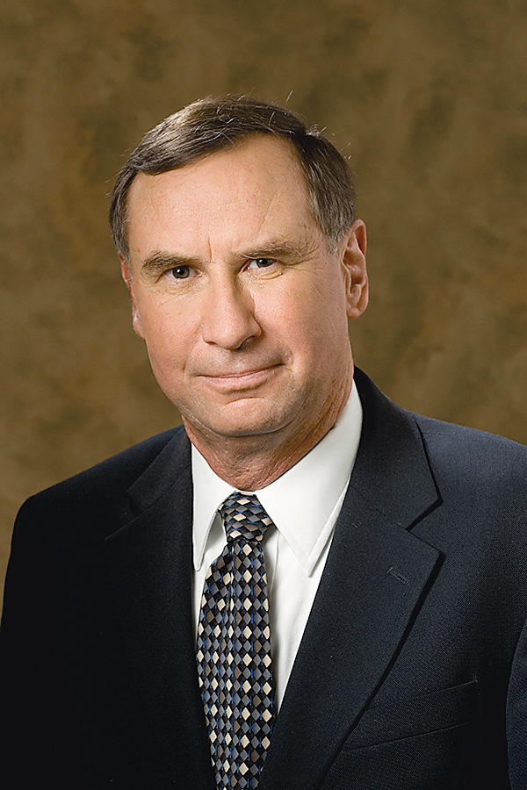
A graduate of the University of Kentucky, May is owner and operator of Mayhaven Farm Seed Sales, an agricultural seed outlet in Waynesburg, Ky., where he owns 330 acres and leases another 700 acres. He is involved in the development and marketing of 500 stocker heifers. May’s operation also includes 200 acres of corn, 200 acres of soybeans, 100 acres of wheat for silage, grain and straw, 150 acres of alfalfa hay for sale to dairy and horse markets. He is a director of Central Kentucky Ag Credit, headquartered in Lexington, Ky., and has served on its board since 1990. May is also active in several farm organizations. He is chairman of the Lincoln County Extension Council, and director for the Lincoln County Farm Bureau. May is a member of the Lincoln County Cattlemen’s Association and the Lincoln County Ag Development Council. May has been a member of the AgFirst board since 2006.

Robert H. Spiers Jr.
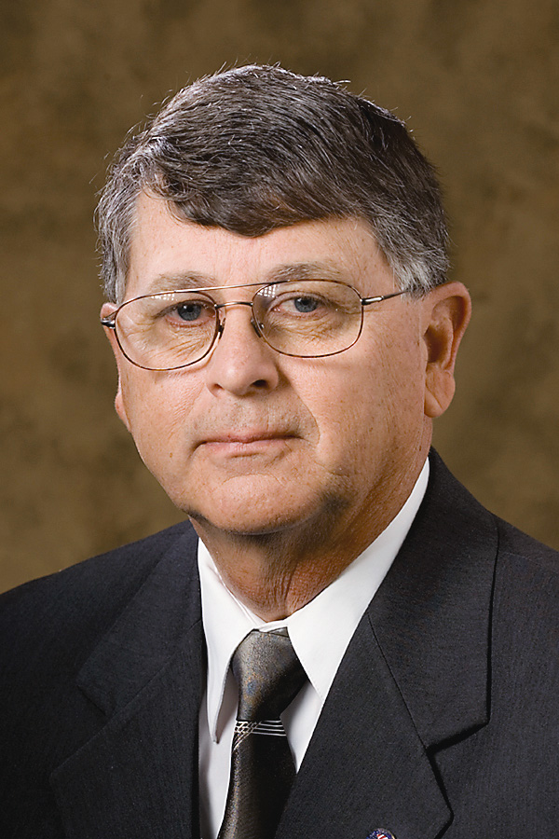
Working in alliance with his son, Spiers farms full-time, growing corn, soybeans, wheat, and tobacco on 1,100 acres in Dinwiddie County, Va. He is a director of Colonial Farm Credit, headquartered in Mechanicsville, Va., and has served on its board since 1980. He is also a director for the Dinwiddie County Farm Bureau, Tobacco Associates, Inc., and the Virginia Flue-Cured Tobacco Board. Spiers has been active in several farming organizations, including the Soil and Water Conservation District Board, the Virginia Peanut Growers Association and Virginia Cotton Growers Association. He is a graduate of Virginia Tech. Spiers has been a member of the AgFirst board since 2006.

M. Wayne Lambertson
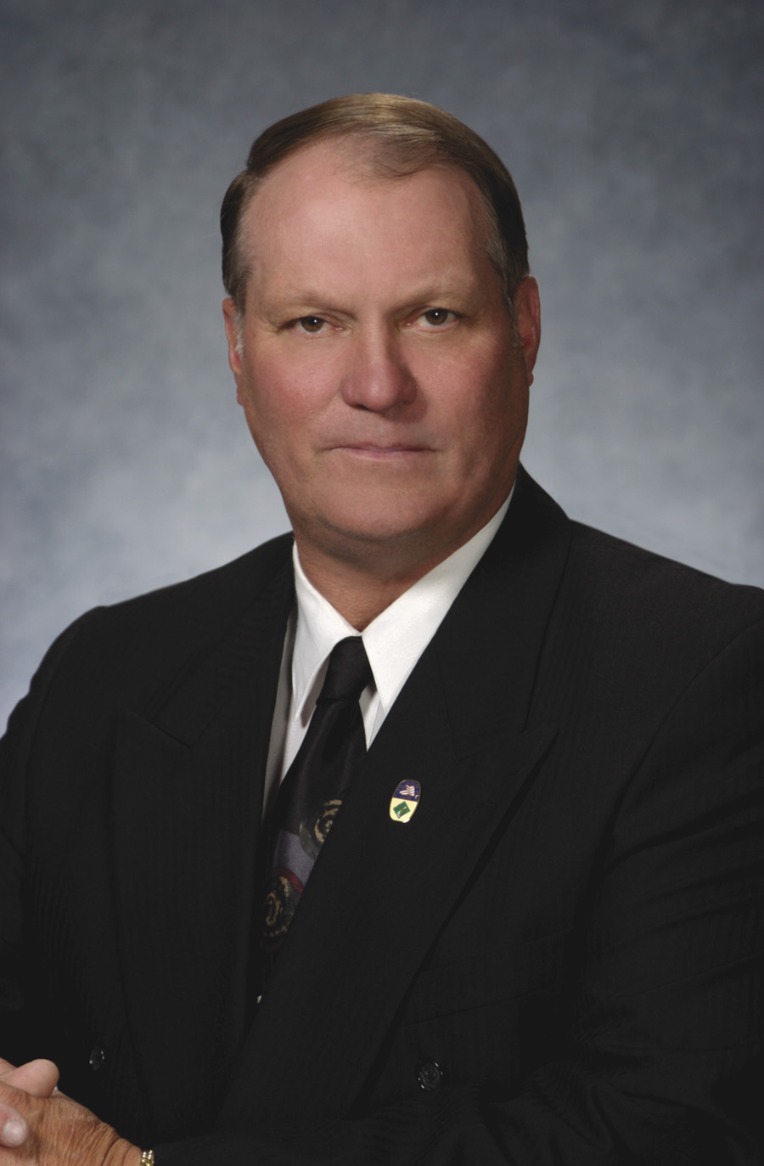
With his son, Lambertson owns and operates Twin Oak Farms, Inc., a 2,000-acre farm on the Eastern Shore of Maryland where he grows corn, soybeans and wheat, and a 175,000-capacity broiler operation. He is co-owner of a restaurant and a partner in a development and construction company. Lambertson is also a partner in Millennium Farms, LLC and Amen Corner, LLC, breeder and broiler operations. He is a director for MidAtlantic Farm Credit, headquartered in Westminster, Md., and has served on its board since 1981. Lambertson is currently a board member for the national Farm Credit Council and was past chairman. He is a member of the Snow Hill Grain, Inc., and Maryland Farm Bureau. Lambertson is a member of the Worcester County Farm Bureau and the Delmarva Poultry Industry, a trade organization. He has been a member of the AgFirst board since 2002.
Other members of the AgFirst board are: Gary L. Alexander, Westminster, S.C.; Dale R. Hershey, Manheim, Penn.; Robert L. Holden Sr., Whigham, Ga.; Paul M. House, Nokesville, Va.; Thomas W. Kelly, Tyrone, Penn.; Lyle Ray King, Ash, N.C.; Eugene W. Merritt Jr. Easley, S.C.; James M. Norsworthy, III, Jackson, La.; Katherine A. Pace, Orlando, Fla.; Walter Schmidlen, Elkins, W. Va.; Robert G. Sexton, Vero Beach, Fla.; William H. Voss, McComb, Miss.; and J. Mark Wheeler, Bradenton, Fla.

###

About AgFirst Farm Credit Bank (www.agfirst.com): AgFirst Farm Credit Bank provides funding and financial services to 22 Agricultural Credit Associations in 15 eastern states and Puerto Rico. These associations, operating as Farm Credit and Ag Credit associations, provide real estate and production financing to 80,000 farmers, agribusinesses, and rural homeowners. AgFirst reported assets of $30 billion as of September 30, 2009.
AgFirst is part of the Farm Credit System, a nationwide network of agricultural and rural lending institutions cooperatively owned by their borrowers. Farm Credit helps maintain and improve the quality of life in rural America and on the farm, through its constant commitment to competitive lending, expert financial services and a feeling of partnership with its customers. The Farm Credit System reported combined assets of $215.2 billion on September 30, 2009.

